**Automated Machine Learning**Automated machine learning, also referred to as autoML, is the process of automating the time-consuming iterative tasks of machine learning model development. It allows data scientists, analysts, and developers to build ML models with high scale, efficiency, and productivity all while sustaining model quality.

Traditional machine learning model development is resource-intensive, requiring significant domain knowledge and time to produce and compare dozens of models. Apply automated ML when you want Azure Machine Learning to train and tune a model for you using the target metric you specify. The service then iterates through ML algorithms paired with featured selections, where each iteration produces a model with a training score. The higher the score, the better the model is considered to “fit” your data.

With automated machine learning, you’ll accelerate the time it takes to get production-ready ML models with great ease and efficiency.

**When to use automated ML**  
Automated ML democratizes the machine learning model development process, and empowers its users, no matter their data science expertise, to identify an end-to-end machine learning pipeline for any problem.

Data scientist, analysts and developers across industries can use automated ML to:  
- Implement machine learning solutions without extensive programming knowledge  
- Save time and resources  
- Leverage data science best practices  
- Provide agile problem-solving

1. Select **AI + Machine Learning** > **Machine Learning service workspace**  
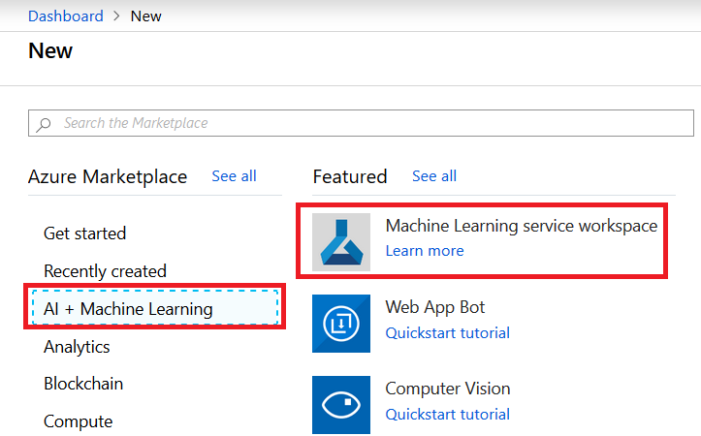

2. Naming the **Workspace Name** > Select **Resource Group** and **Location**. Click on **Review + Create**.  
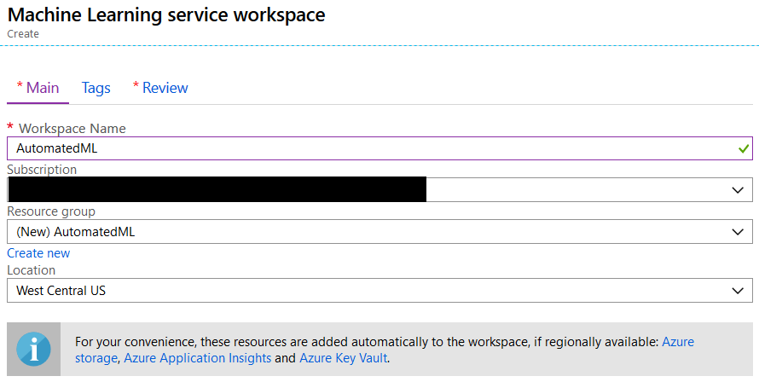

3. Click on **Create** button.

4. Click on **Go to resource** button.  
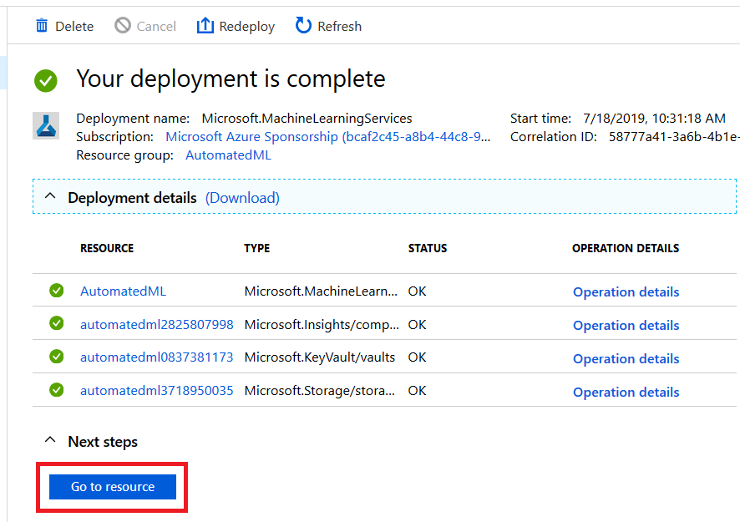

5. Click on **Create a new Automated Machine Learning Model (Preview)**.  
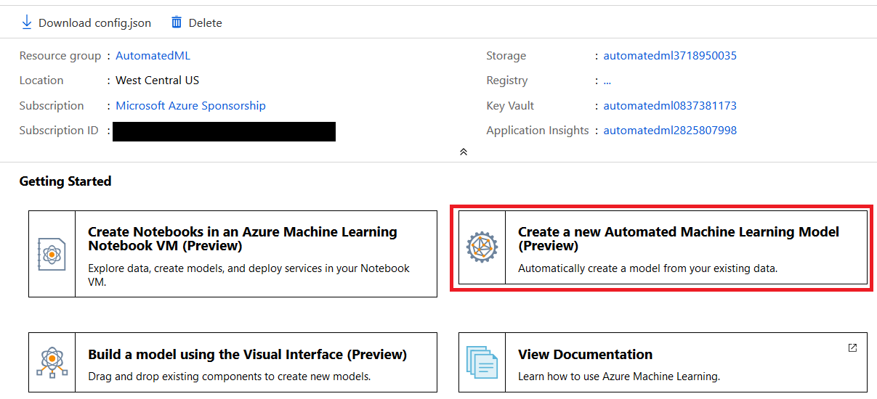

6. Click on **Create experiment** button  
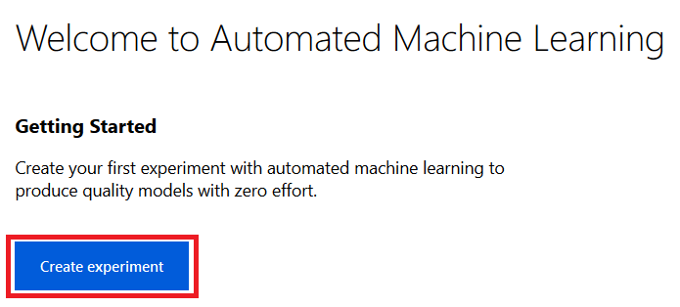

7. Give **Experiment name** and **Select a training compute**. In case you did not have a Compute, you need to crate one that specifies the size of the virtual machine that model is going to run on it.  
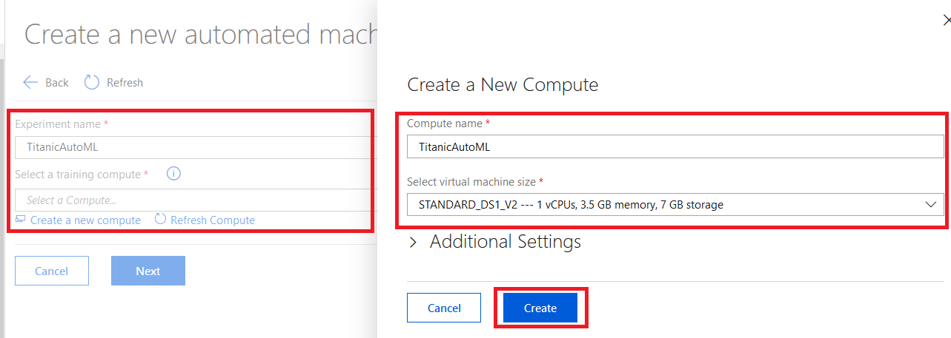

8. **Select a training compute that you created** in previous step and click on **Next** button.  
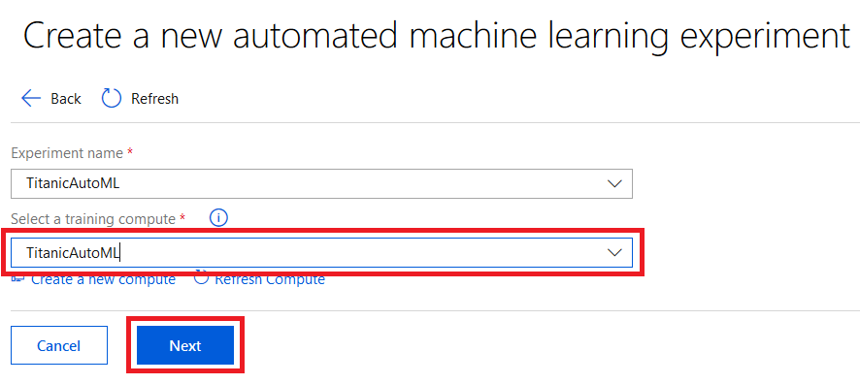

9. Click on **Upload** button to upload the dataset  
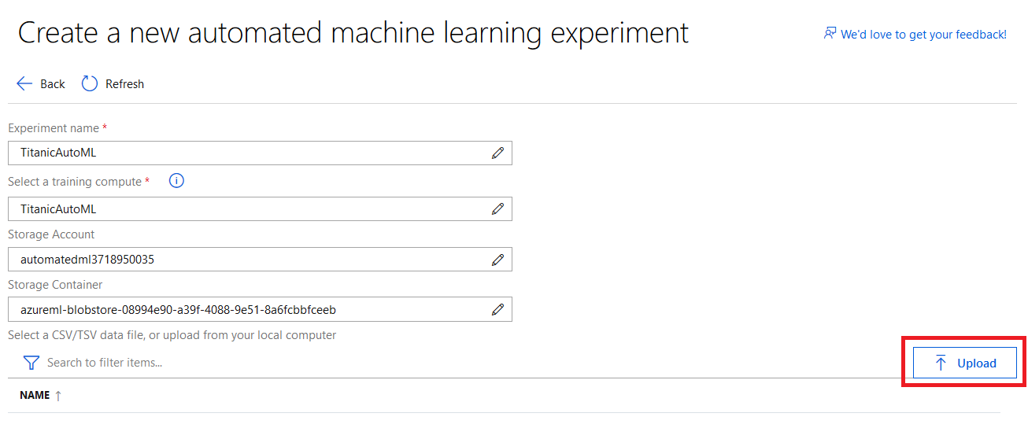

10. Click on the dataset that you uploaded.  
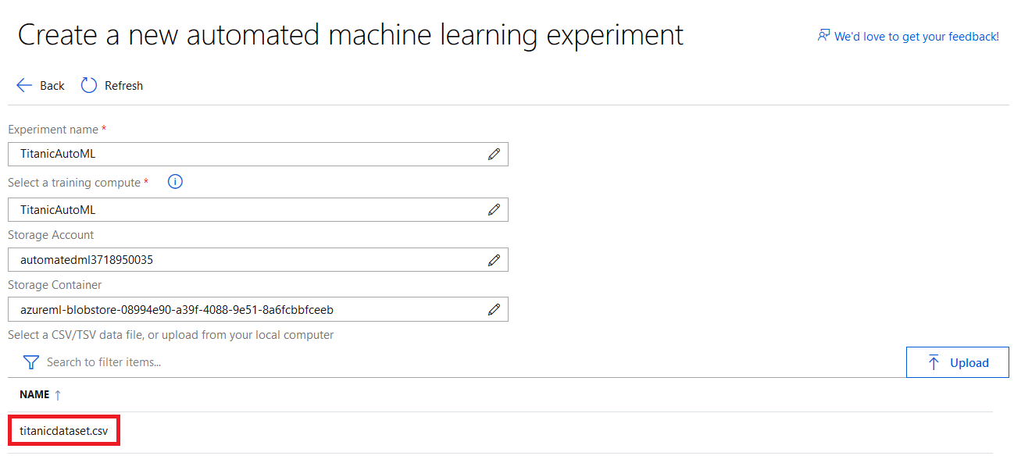

11. Select **Prediction Task** like Classification and so on. In this scenario, we going to predict passenger in the Titanic Ship will survive or not.  
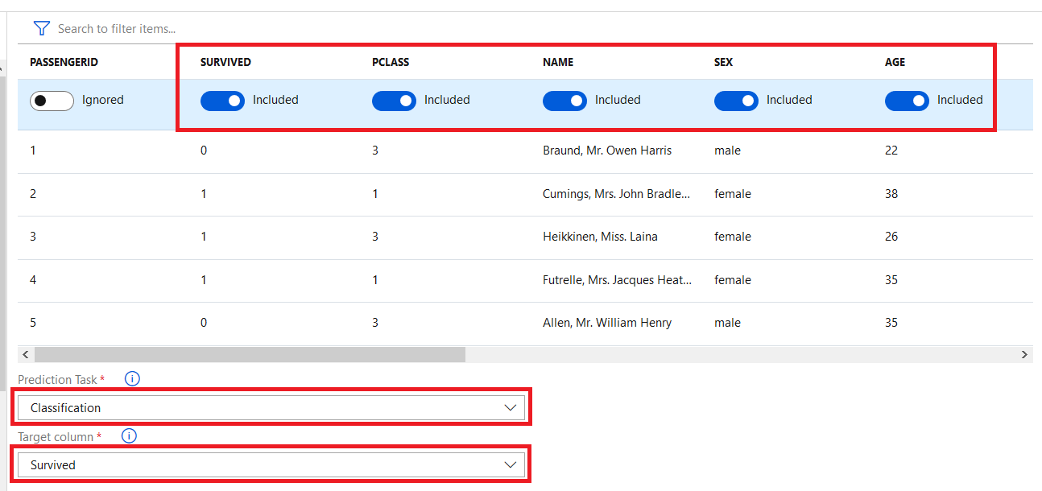

12. In **Advanced Settings**, we able to identify the **accuracy parameters**, **training job time**, the **maximum number of iterations**, some preprocessing tasks like **cross validations process**, **concurrency of iteration**.  
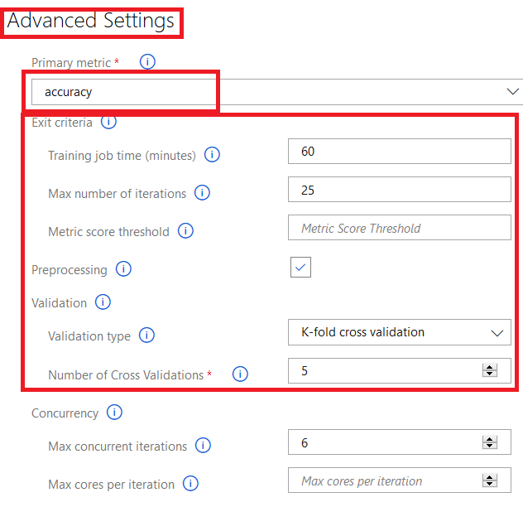

13. Select the Algorithms you needed to see which on works better for your dataset and click on **Start** button.  
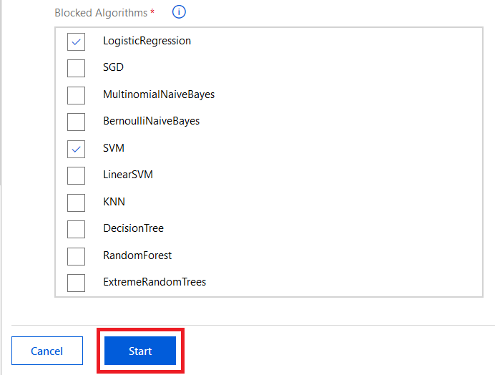

14. Go to Automated machine learning, you will see the list of experiment you have, whether they are running Completed, Failed or another situation.  
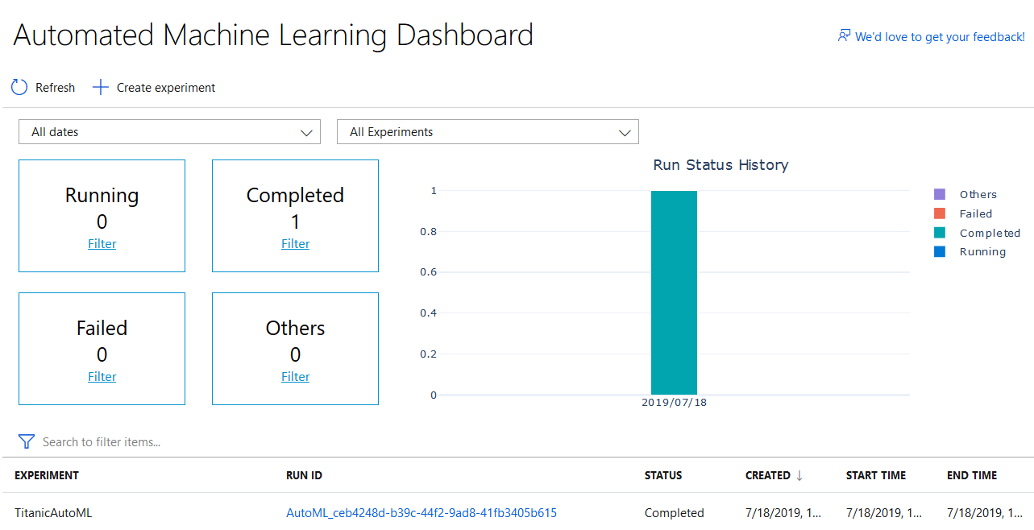

15. Click on the **Experiment** that you created.  
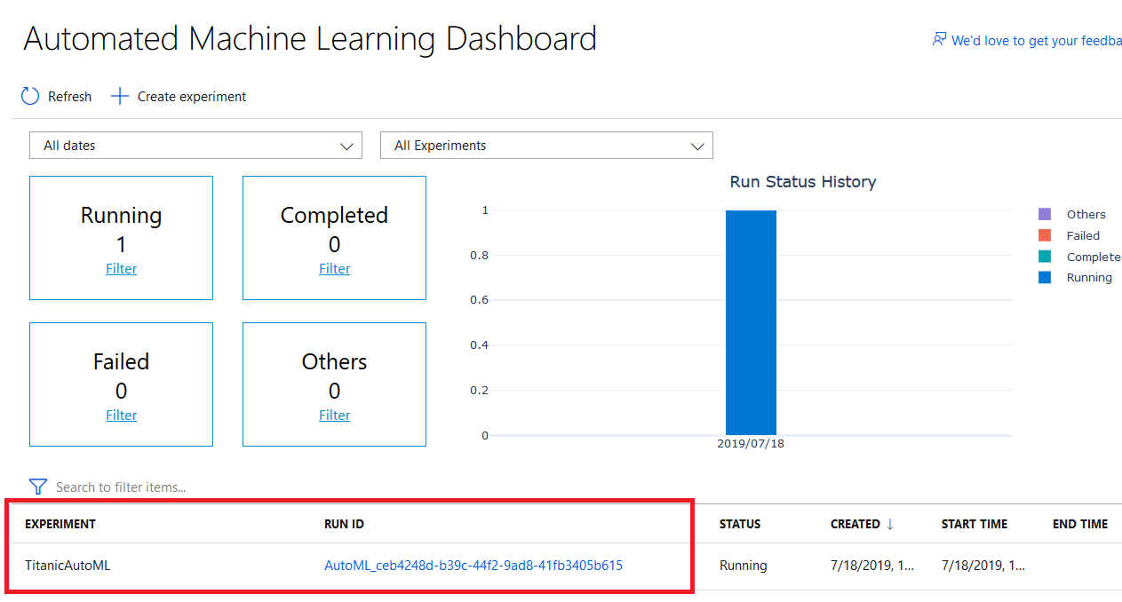

16. Clicks on the **Logs** to see a list show in the recent update and what steps the AutoML is and the list is completing.  
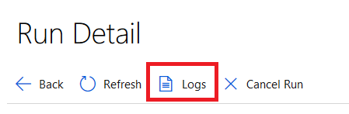

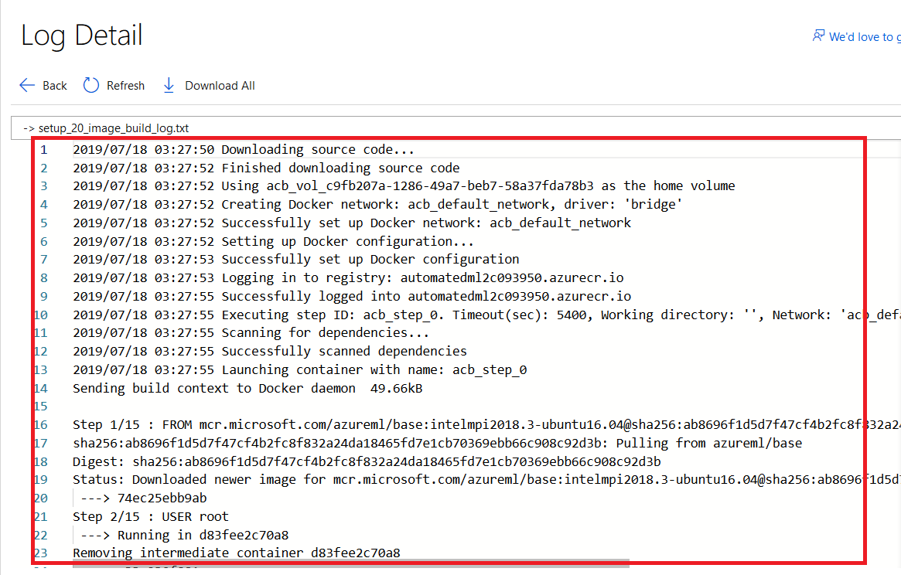

17. You able to see a chart that shows the iteration, which algorithms archive the accuracy level.  
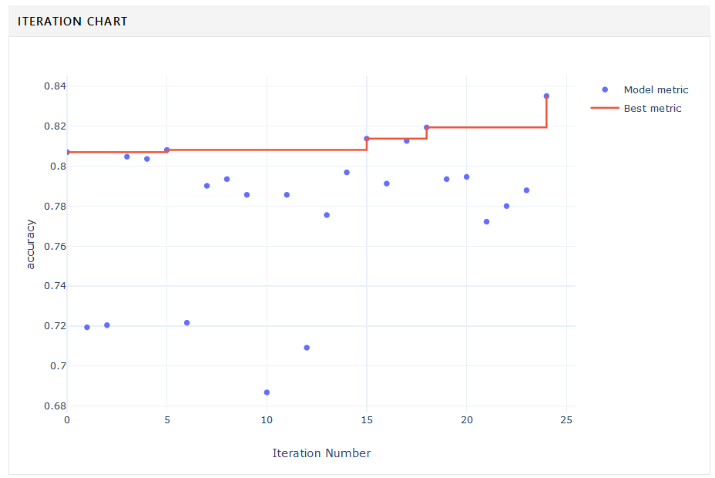

18. Click on each of these algorithms that has been listed and sorted based on their accuracy.  
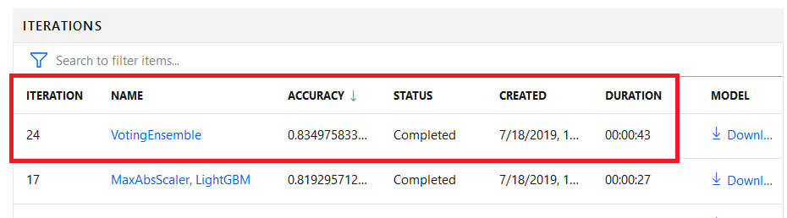

19. The detailed explanation of these algorithms will be shown to you like the accuracy.

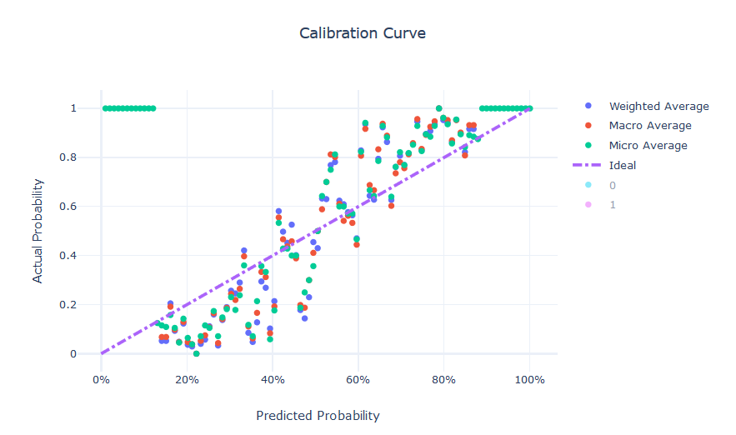

OR a confusion matric for classification accuracy analysis.  
